
MOSFET Characteristics
Nanotechnology and Nanoelectronics Engineering
Zewail City of Science, Technology and Innovation
Analog IC Design NANENG 332– Fall 2026
Youssef Ahmed Mohamed ID: 202401212

1. Introduction
In this lab we characterize an NMOS transistor using Cadence Virtuoso. The device is the nch transistor of the 65 nm design kit, with L_{n} = 60 nm, W_{n} = 200 nm, M_{n} = 1 and F_{n} = 1 as the default values. We run DC sweeps on V_{GS} and V_{DS} and study how the channel length, the channel width, the number of fingers and the multiplier change the characteristics. After that we check the device across process, voltage and temperature (PVT) corners, and finally we look at the transconductance g_{m}.

2. Task 1: DC Sweep on V_{GS}
Figure 1 shows the testbench schematic.
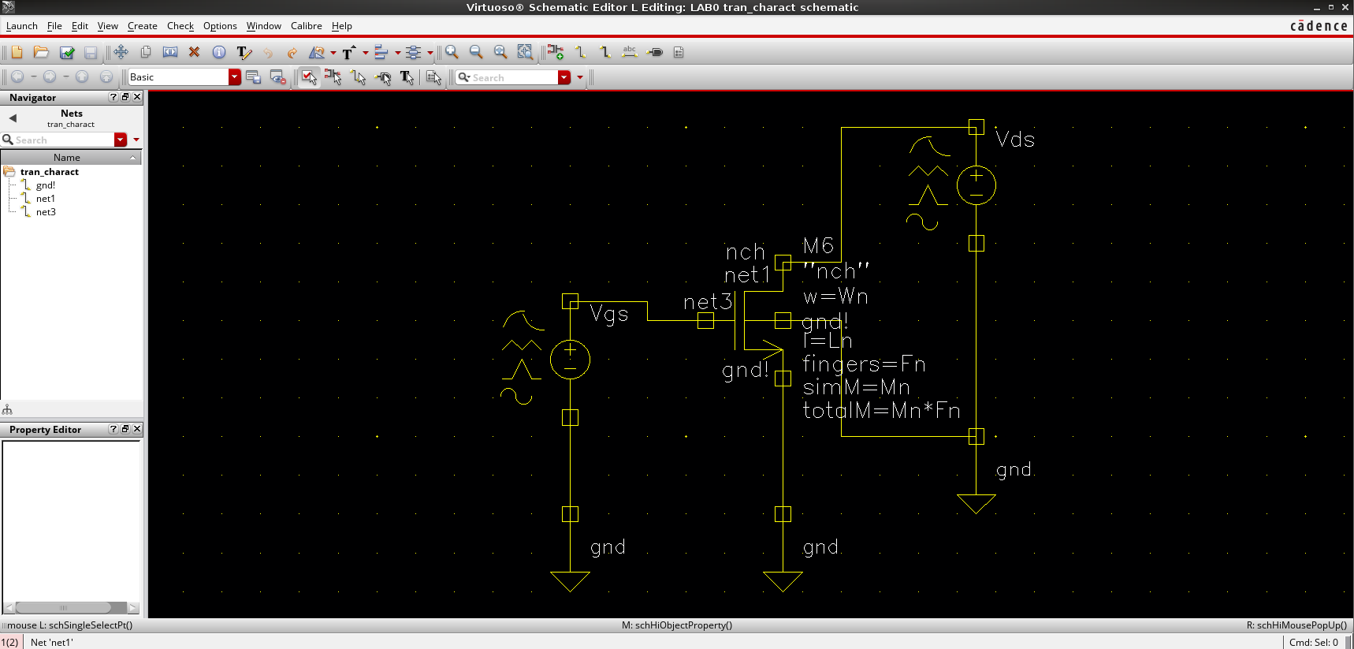
Figure 1: Testbench schematic used to characterize the NMOS device.

I_{D} versus V_{GS} and the threshold voltage
V_{GS} was swept from 0 to 1.2 V with a step of 10 mV while making Vdd =800mV Figure 2 shows the resulting I_{D} versus V_{GS} curve, and from the graph we can estimate that V_{TH} is about 0.35 V.
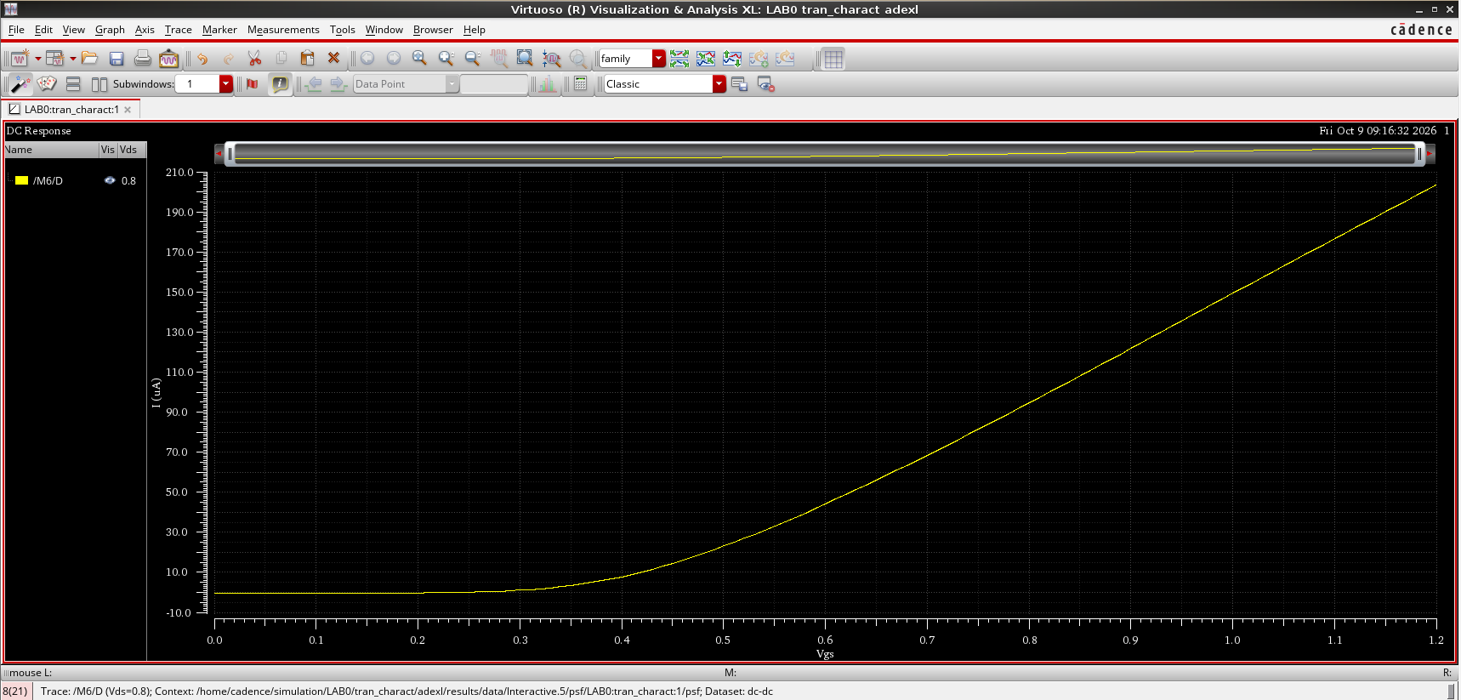
Figure 2: I_{D} versus V_{GS} at V_{DS} = 800 mV.

We can estimate Vth = 0.4V from the graph

Effect of the channel length
Here we define the parametric sweep of L_{n}, from 60n to 240n with 4 points (Figure 3). Figure 4 shows I_{D} versus V_{GS} for the different lengths. Clearly, increasing L reduces I_{D}.
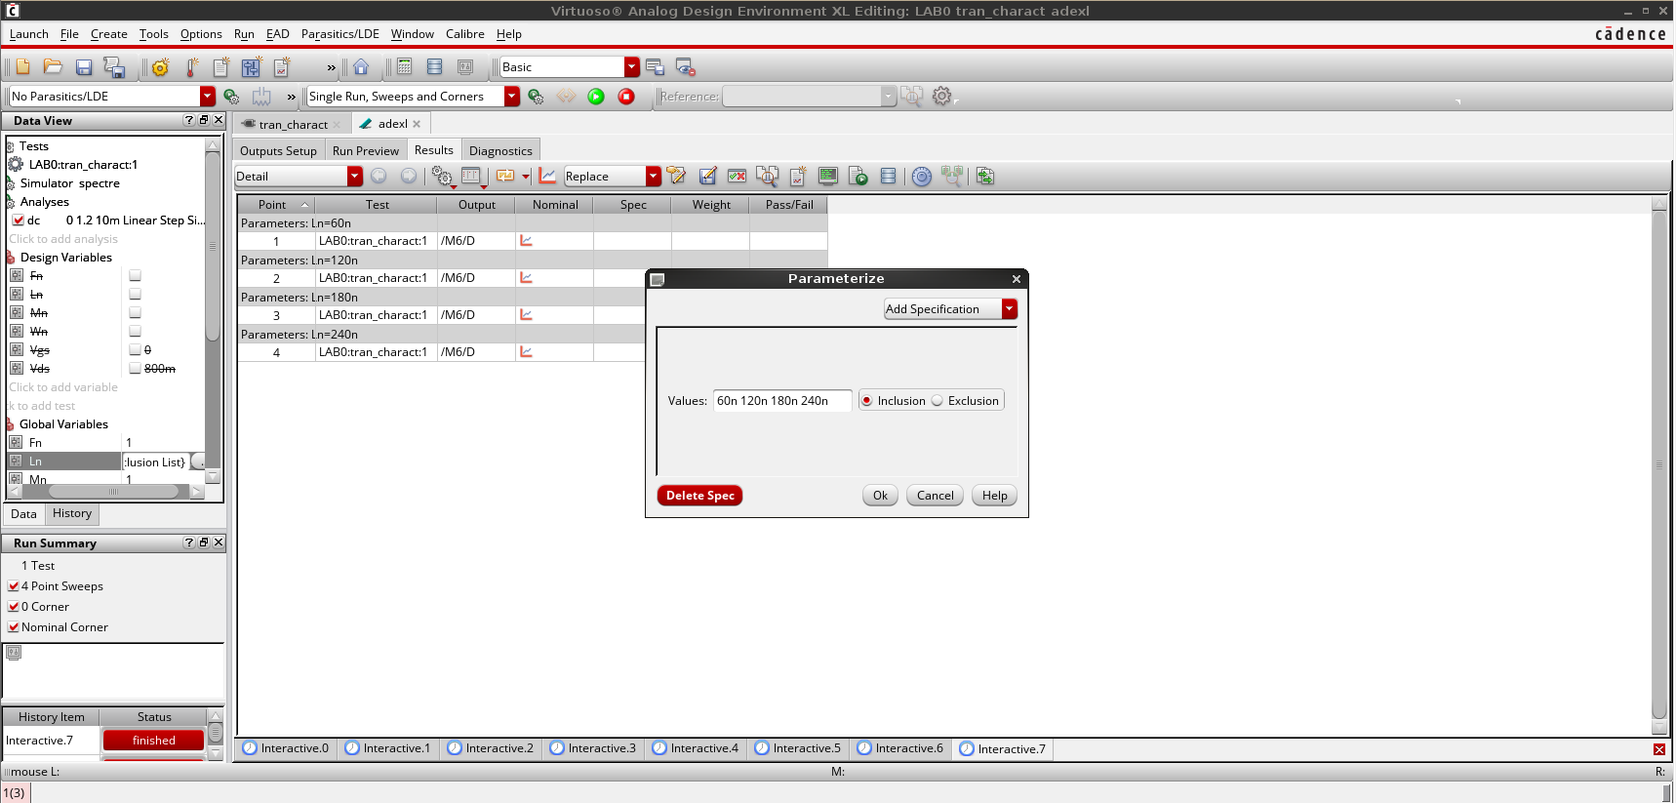
Figure 3: Parametric sweep setup for L_{n}.
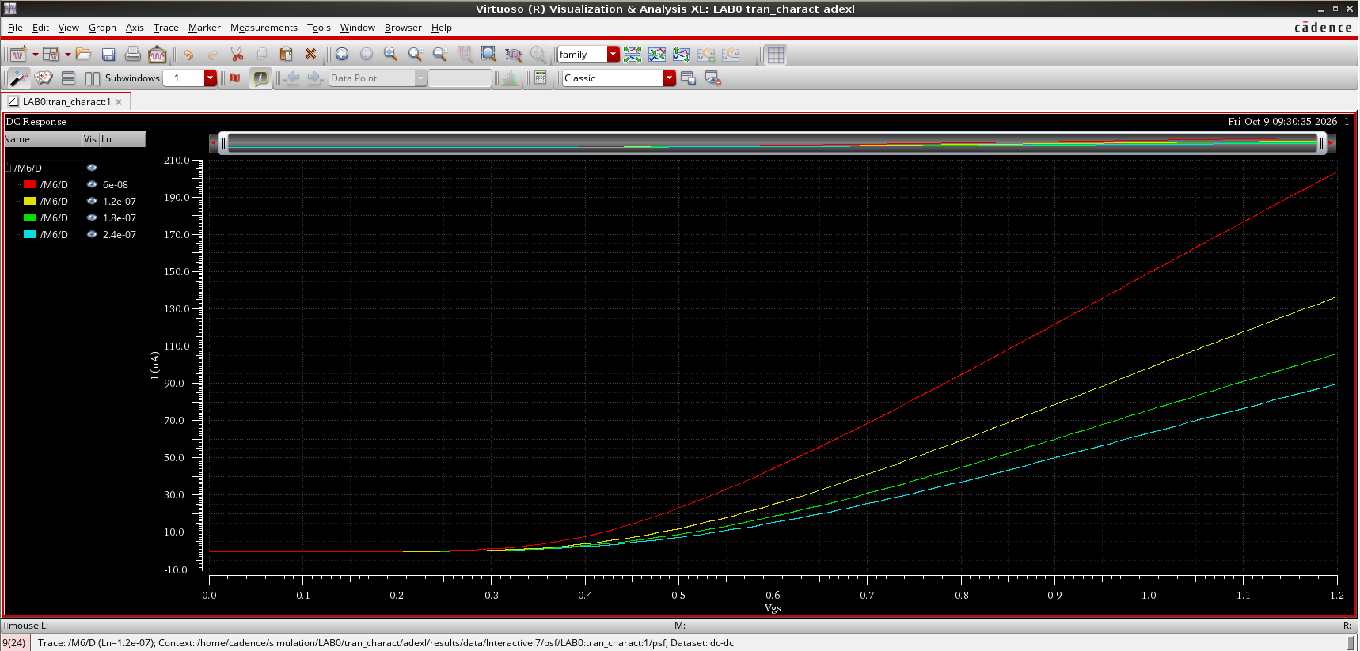
Figure 4: I_{D} versus V_{GS} for different channel lengths.

Effect of the channel width
After returning L_{n} back to 60n, we sweep W_{n} from 150n to 5u with a step count of 4 (Figure 5). Figure 6 shows I_{D} versus V_{GS} for the different widths. Increasing W_{n} increases I_{D}.
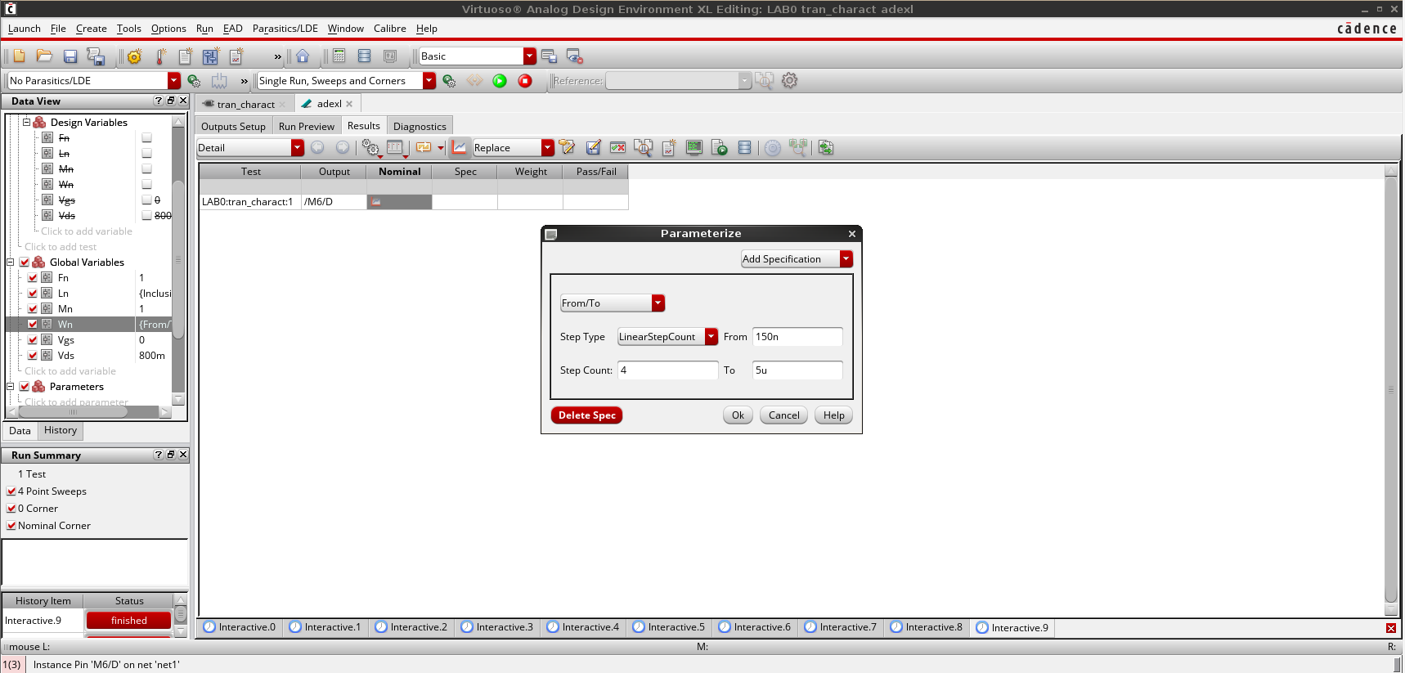
Figure 5: Parametric sweep setup for W_{n} (150n to 5u, 4 points).
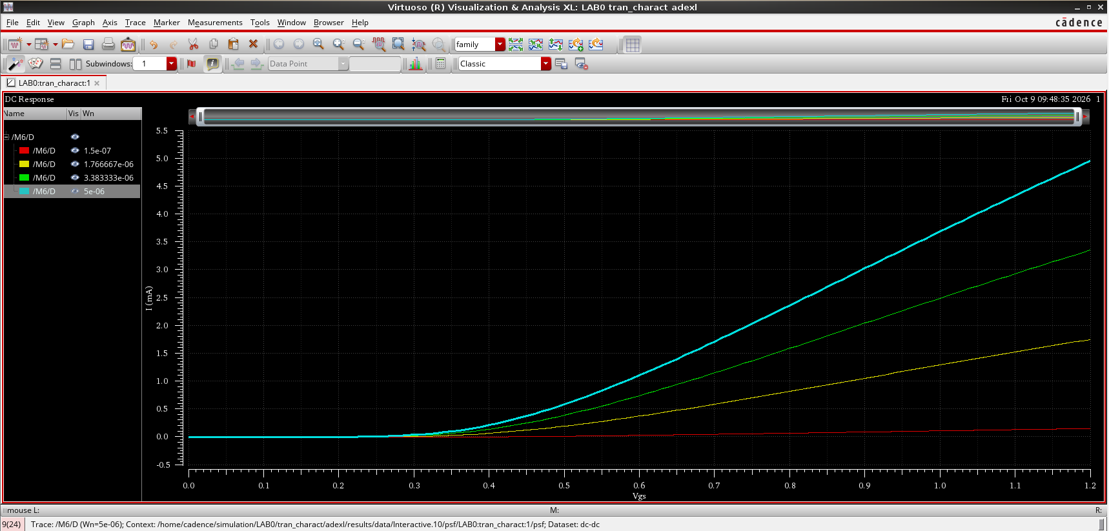
Figure 6: I_{D} versus V_{GS} for different channel widths.

Effect of the number of fingers
Next we sweep F_{n} from 1 to 5 with a step count of 5 (Figure 7). Figure 8 shows V_{GS} on the x-axis and I_{D} on the y-axis for the different values of F_{n}. Increasing F_{n} increases I_{D}.
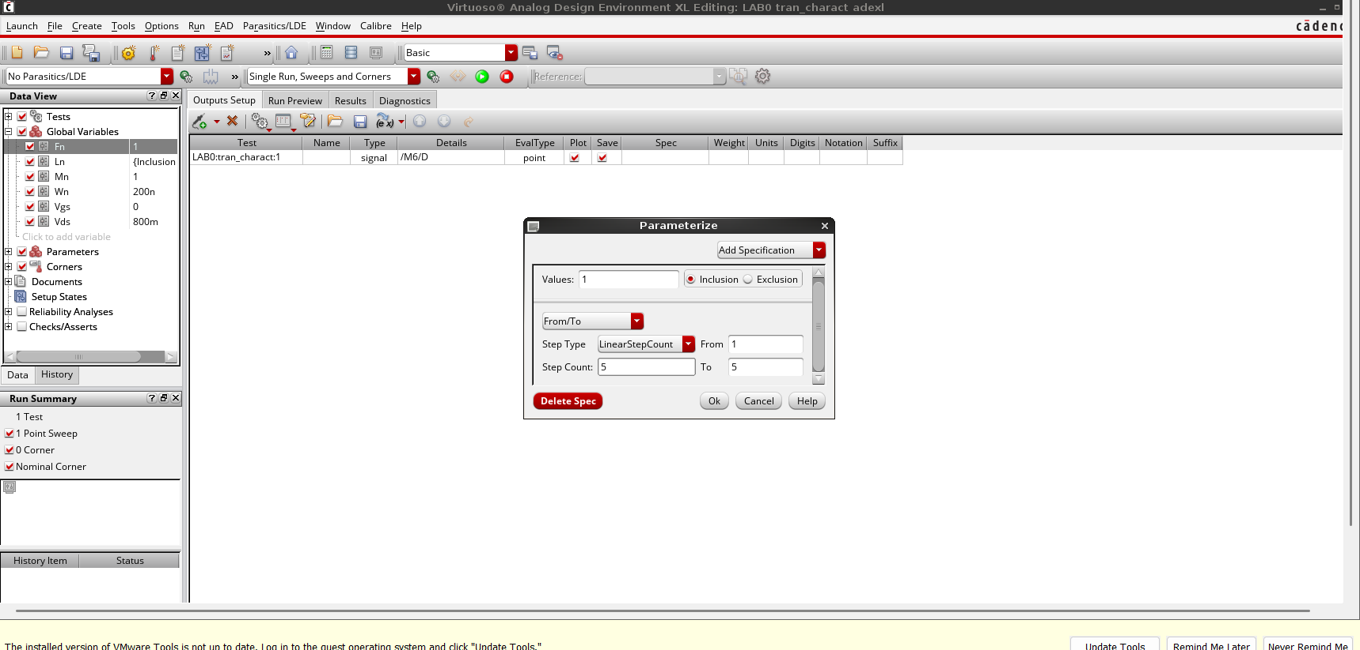
Figure 7: Parametric sweep setup for F_{n} (1 to 5, 5 points).
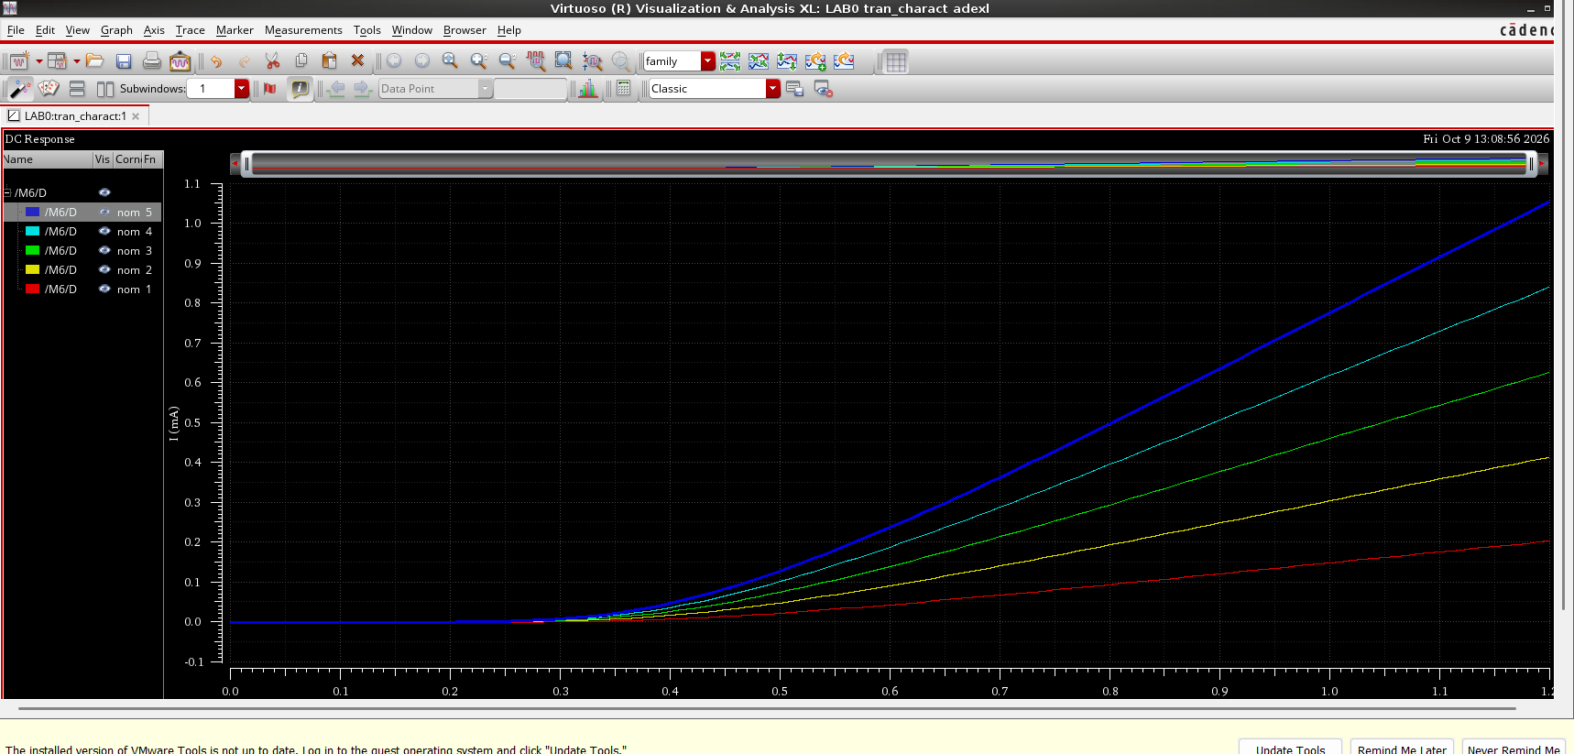
Figure 8: I_{D} versus V_{GS} for different numbers of fingers.

Effect of the multiplier
Figure 9 shows I_{D} versus V_{GS} for different values of M_{n}, from 1 to 5 with a step count of 5. Increasing M_{n} also increases I_{D}.
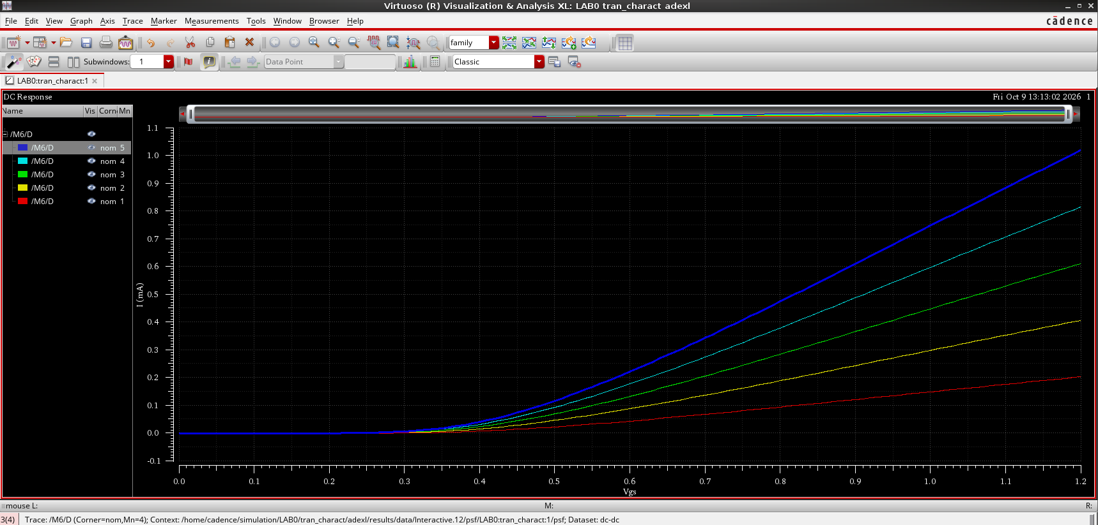
Figure 9: I_{D} versus V_{GS} for different multipliers (M_{n} = 1 to 5).

Question
Is it possible to sweep the gate thickness?
No. In physical manufacturing, the gate oxide thickness (T_{ox}) is set during wafer fabrication. The analog designer does not design vertical parameters like T_{ox}. The designer only controls the lateral dimensions (W and L), the number of fingers and the multiplier.

3. Task 2: DC Sweep on V_{DS}
Here we sweep V_{DS} instead of V_{GS}. V_{DS} is swept from 0 to 1.2 V with a 10 mV step (Figure 10), and V_{GS} is set to V_{TH} + 300 mV = 650 mV (Figure 11).
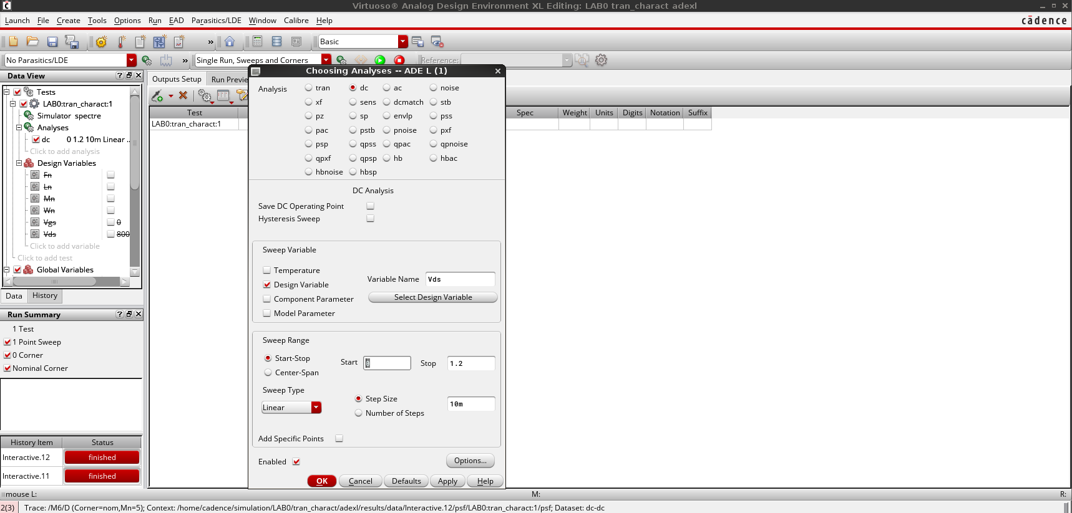
Figure 10: DC analysis setup: V_{DS} swept from 0 to 1.2 V with a 10 mV step.
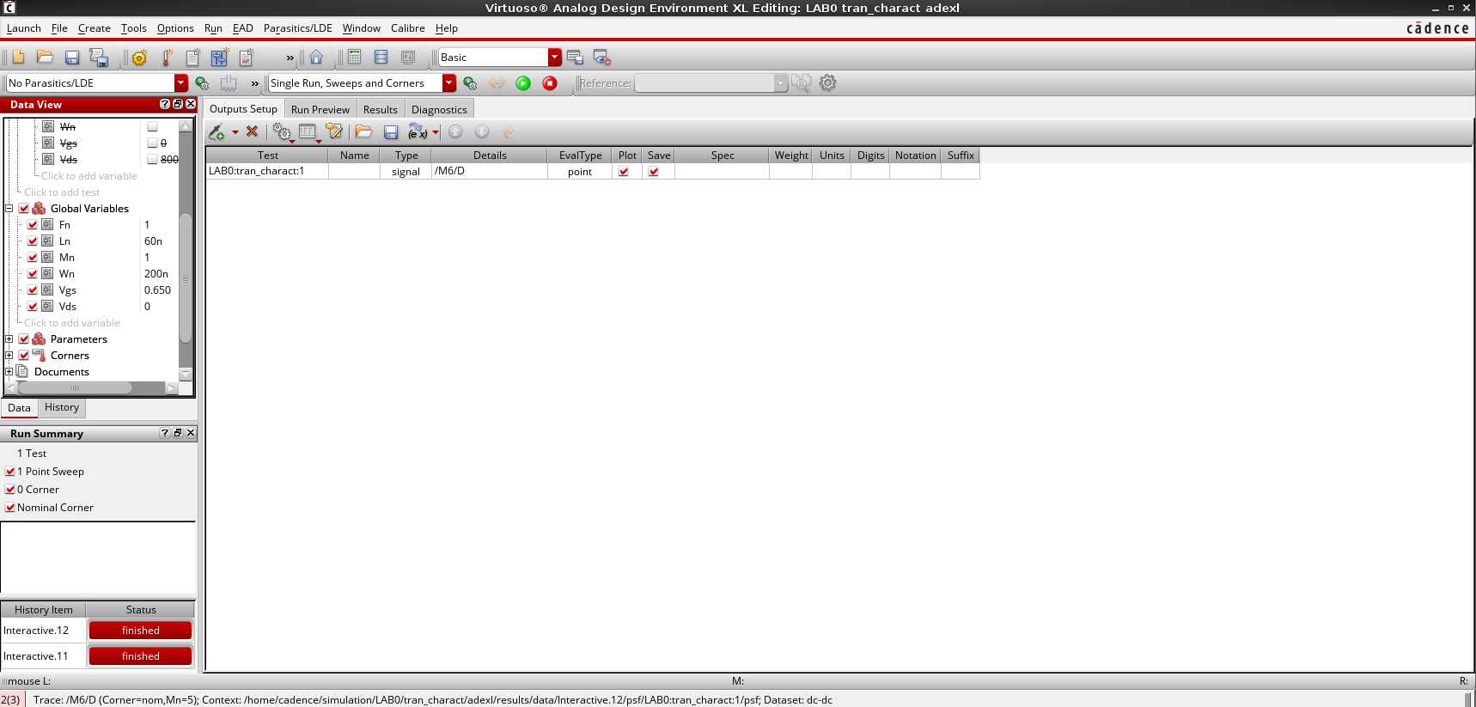
Figure 11: Design variables with V_{GS} set to 0.65 V.

I_{D} versus V_{DS} and the operating regions
Figure 12 shows I_{D} versus V_{DS}. We can clearly see that the triode (linear) region goes from V_{DS} = 0 V to about 0.15 V, and from 0.15 V up to 1.2 V (the end of the sweep) the device is in the saturation region. This is lower than the long-channel estimate V_{GS} − V_{TH} = 0.3 V, because velocity saturation makes a short-channel device saturate earlier. At V_{GS} = 650 mV the transistor is above threshold along the whole sweep, so there is no cut-off region on this curve. The cut-off region appears when V_{GS} is below V_{TH}, as in Figure 14.
We can also see from the graph that the transistor is not fully saturated. This is due to channel length modulation: I_{D} depends on L_{eff}, and L_{eff} depends on V_{DS}, so there is still some dependence between I_{D} and V_{DS} in the saturation region. In a 60 nm device, DIBL also adds to this effect.
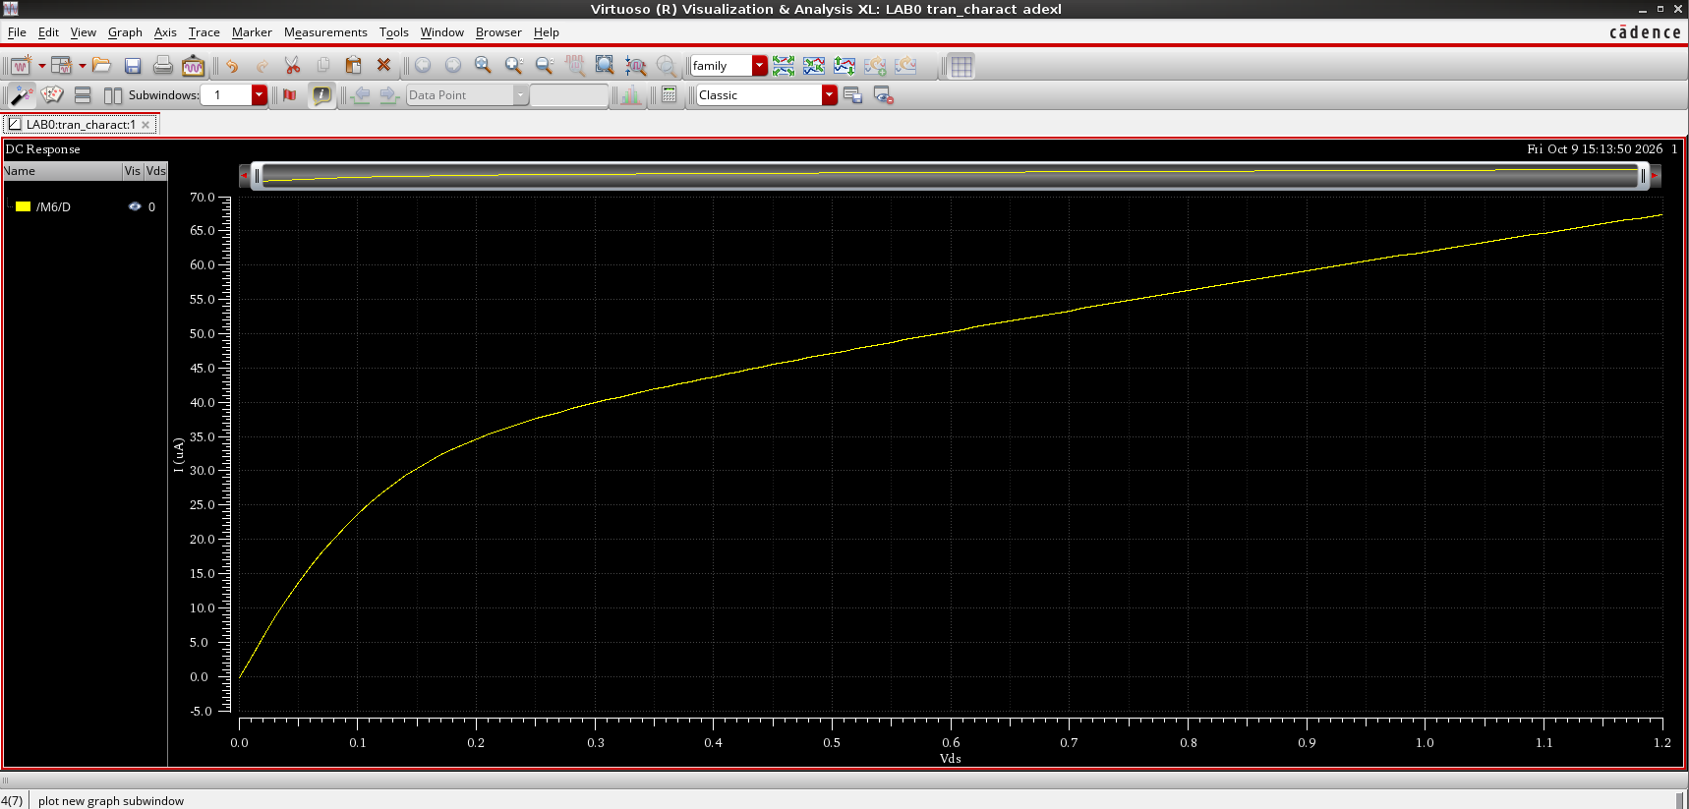
Figure 12: I_{D} versus V_{DS} at V_{GS} = 650 mV.

Effect of V_{GS}
Now we sweep V_{GS} as well, from 0 to 1.2 V (Figure 13). Figure 14 shows I_{D} versus V_{DS} for the different values of V_{GS}. When V_{GS} is smaller than V_{TH}, like the red (0 V) and yellow (0.3 V) curves, there is no I_{D} regardless of V_{DS}, because there are not enough charge carriers to make the channel conduct. Increasing V_{GS} increases the number of charge carriers in the channel. Once V_{GS} becomes bigger than V_{TH}, as in the other curves, the current starts to flow, and a higher V_{GS} means more charge carriers and hence a higher I_{D}.
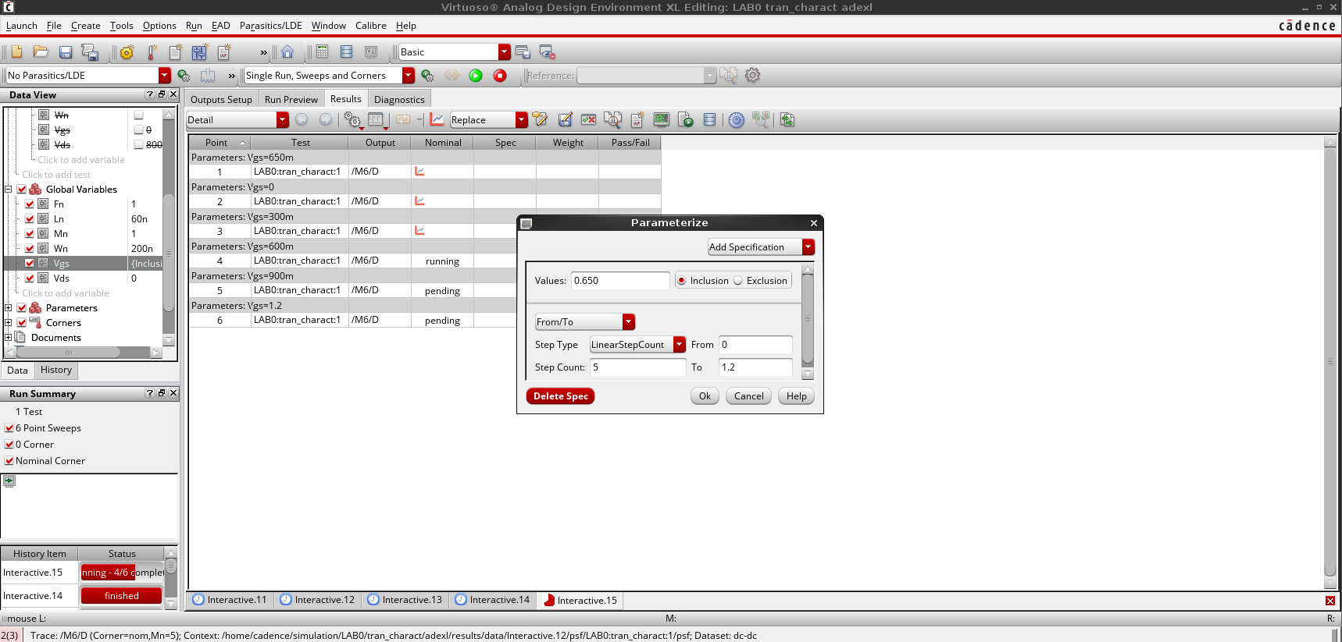
Figure 13: Parametric sweep setup for V_{GS}.
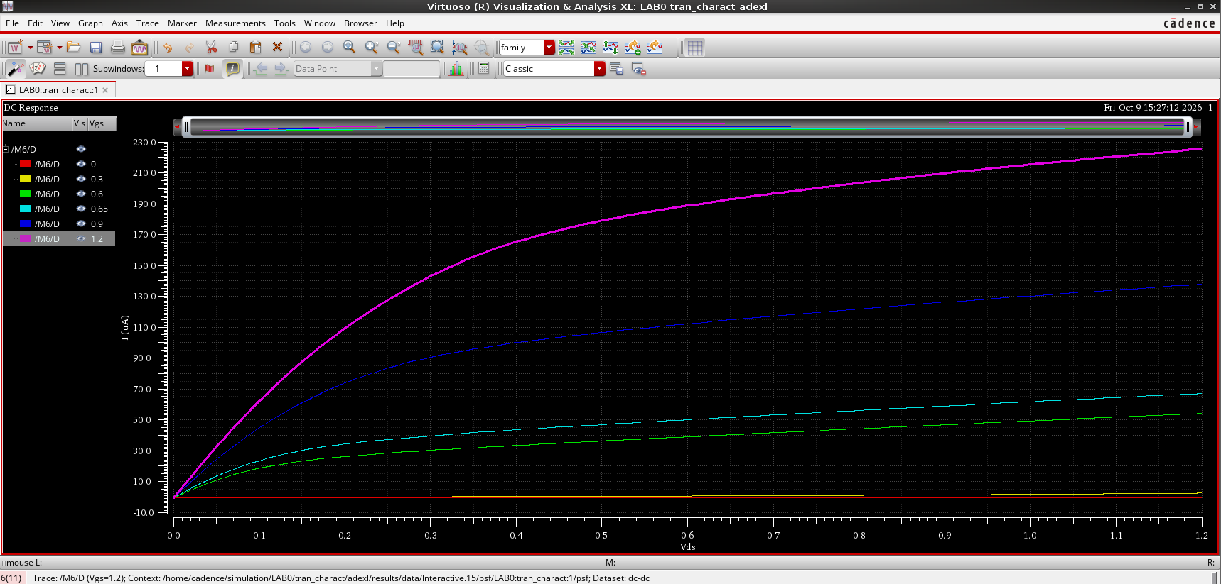
Figure 14: I_{D} versus V_{DS} for different values of V_{GS}.

Effect of the channel length
We sweep L_{n} again, now with the V_{DS} sweep (Figure 15). Figure 16 shows I_{D} versus V_{DS} for the different values of L_{n}, and we clearly see the inverse proportionality between I_{D} and L.
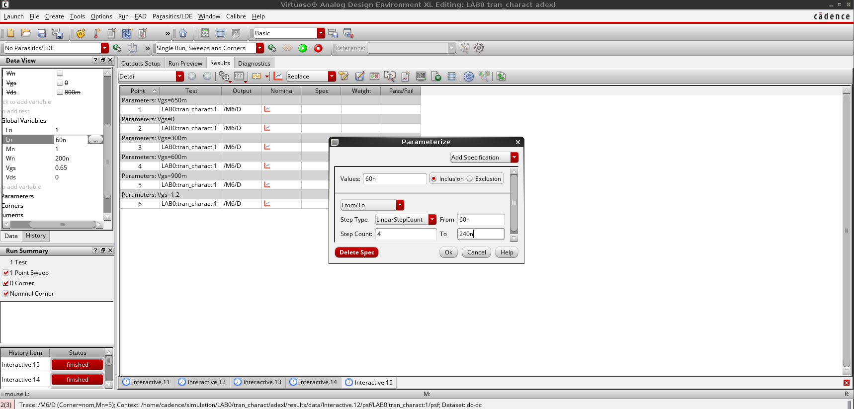
Figure 15: Parametric sweep setup for L_{n} (V_{DS} sweep).
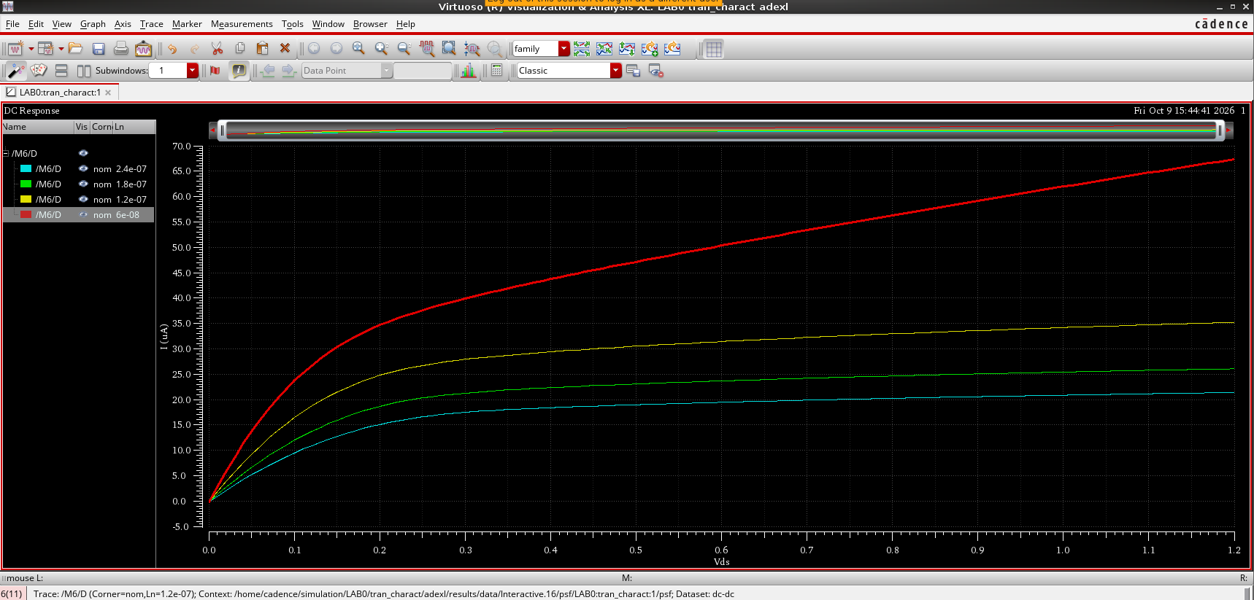
Figure 16: I_{D} versus V_{DS} for different channel lengths.

Effect of the width, fingers and multiplier
Figure 17, Figure 18 and Figure 19 show the results of sweeping W_{n}, F_{n} and M_{n} respectively. In the three cases I_{D} increases as the parameter increases.
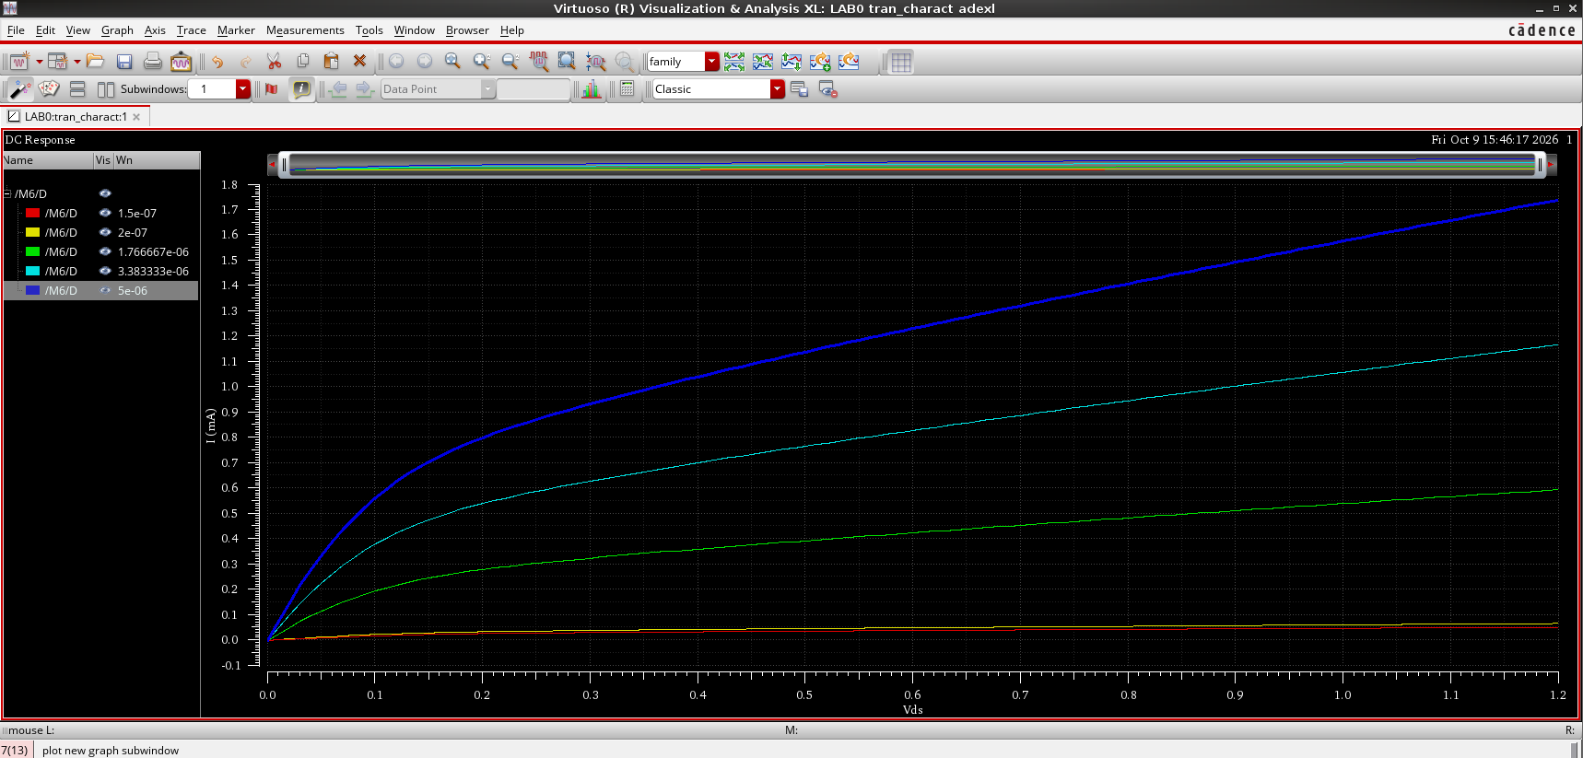
Figure 17: I_{D} versus V_{DS} for different channel widths.
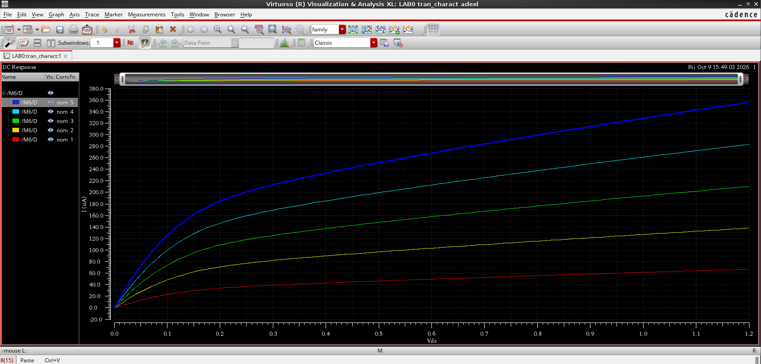
Figure 18: I_{D} versus V_{DS} for different numbers of fingers.
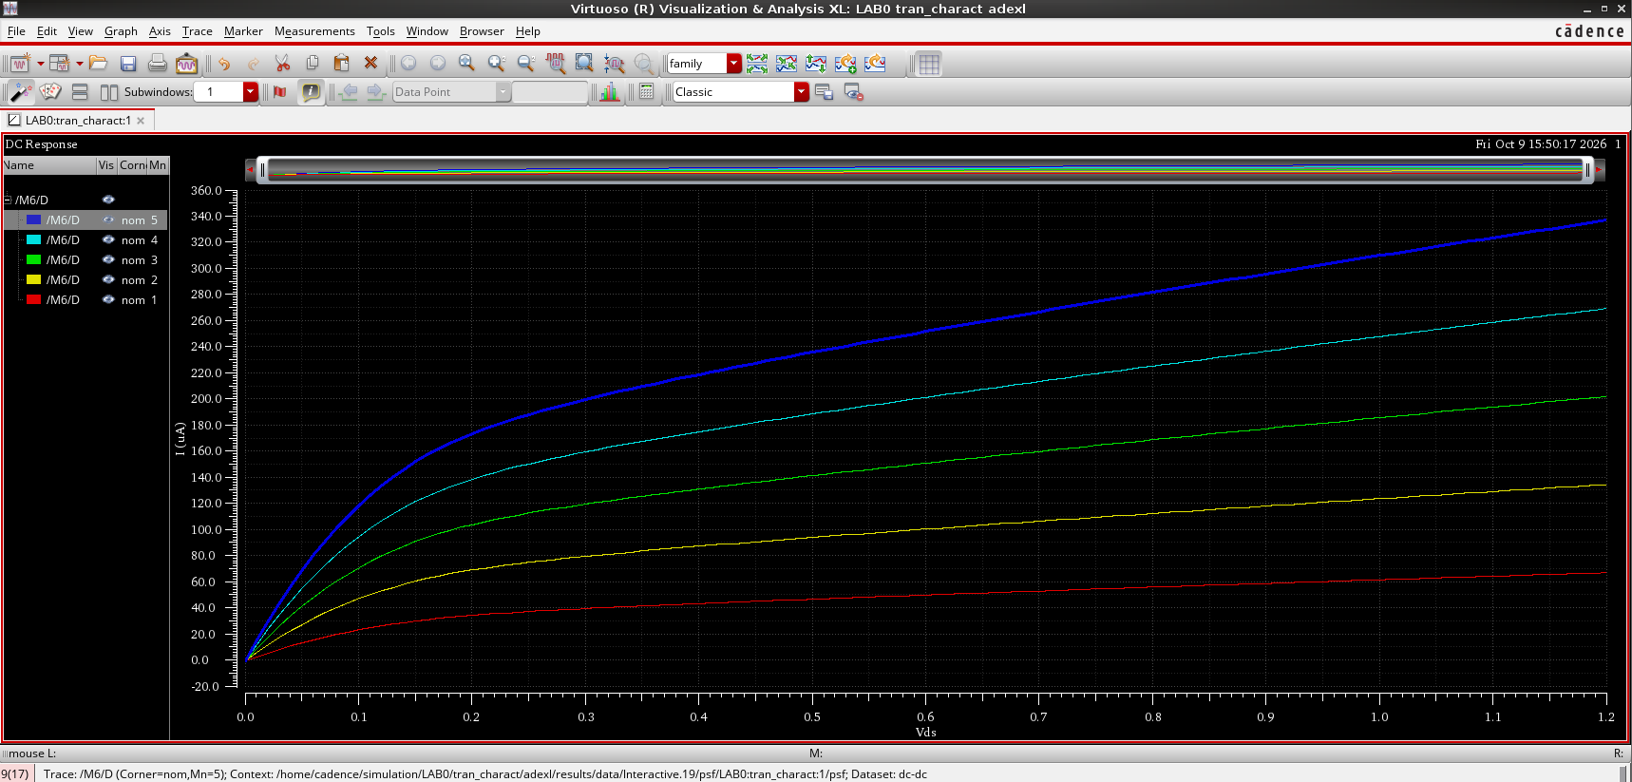
Figure 19: I_{D} versus V_{DS} for different multipliers.

Question
What is the difference between the results when sweeping on F_{n}, M_{n} and W_{n}?
In standard DC simulations, sweeping the width (W_{n}), the number of fingers (F_{n}) or the multiplier (M_{n}) will all increase the drain current I_{D}. M_{n} places identical copies of the transistor in parallel, and F_{n} splits the transistor into fingers inside one device, so in our results F_{n} and M_{n} give almost the same curves (I_{D} is multiplied by the sweep factor). W_{n} makes the transistor itself wider, and here it covers a much bigger range (150 nm to 5 µm), so the change in I_{D} is much large.

4. Task 3: PVT Corner Analysis
In this task we check the device across process, voltage and temperature corners. The process corners are fast, typical and slow NMOS (FF, TT, SS), the voltage corners are V_{DD} + 10%, V_{DD} and V_{DD} − 10% (1.32 V, 1.2 V and 1.08 V), and the temperature corners are hot, room and cold (125 °C, 27 °C and −40 °C). The corners were set up as shown in Figure 20.
We made the fast corner happen at the high temperature and the high supply, the typical corner at room temperature and the slow corner at the low temperature. A higher temperature increases the intrinsic carrier concentration, which lowers the Fermi potential and therefore lowers V_{TH} (typically by around 1 to 2 mV per °C), so the fast corner ends up with the lowest threshold voltage.
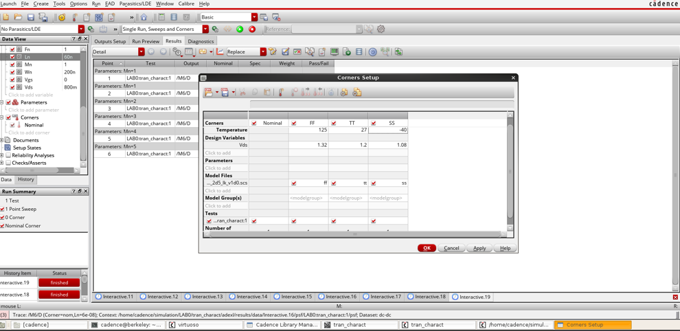
Figure 20: Corners setup: FF (125 °C, 1.32 V), TT (27 °C, 1.2 V) and SS (−40 °C, 1.08 V).

I_{D} versus V_{GS} and the threshold voltage
Figure 21 shows I_{D} versus V_{GS} for the different cases: FF at high temperature, TT at room temperature and SS at low temperature, each with a different V_{DD}. This lets us check the limits of our device before sending it for manufacturing. The FF corner gives the highest current and the SS corner gives the lowest.
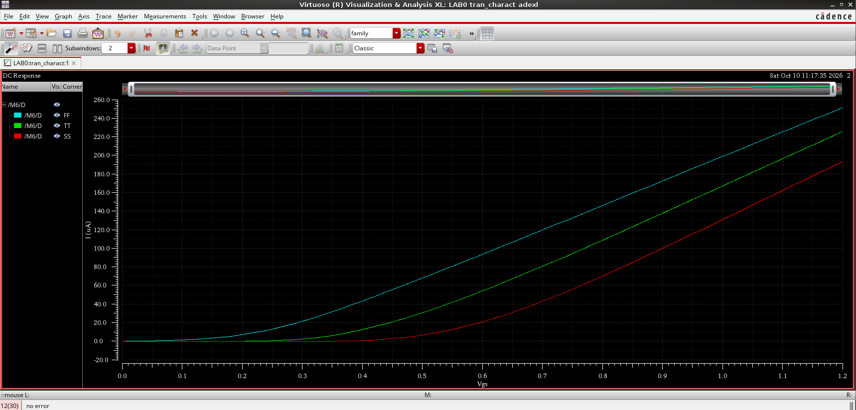
Figure 21: I_{D} versus V_{GS} across the PVT corners (FF, TT, SS).
Different temperature, V_{DD} and process combinations correspond to different values of V_{TH}. We calculated V_{TH} using a function in the Cadence calculator, and Figure 22 shows the results: 156.1 mV for FF, 347.4 mV for TT and 498.8 mV for SS (the nominal value is 373.8 mV).
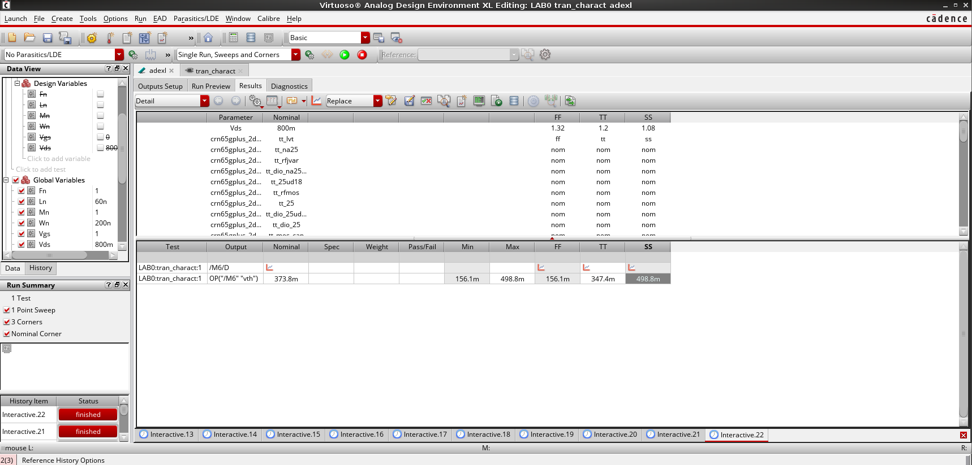
Figure 22: V_{TH} of each corner calculated with the Cadence calculator.

I_{D} versus V_{DS}
Figure 23 shows I_{D} versus V_{DS} at a fixed V_{GS} for the three corners. It shows how the device behaves at the extremes of the PVT range, with FF again giving the highest current and SS the lowest.
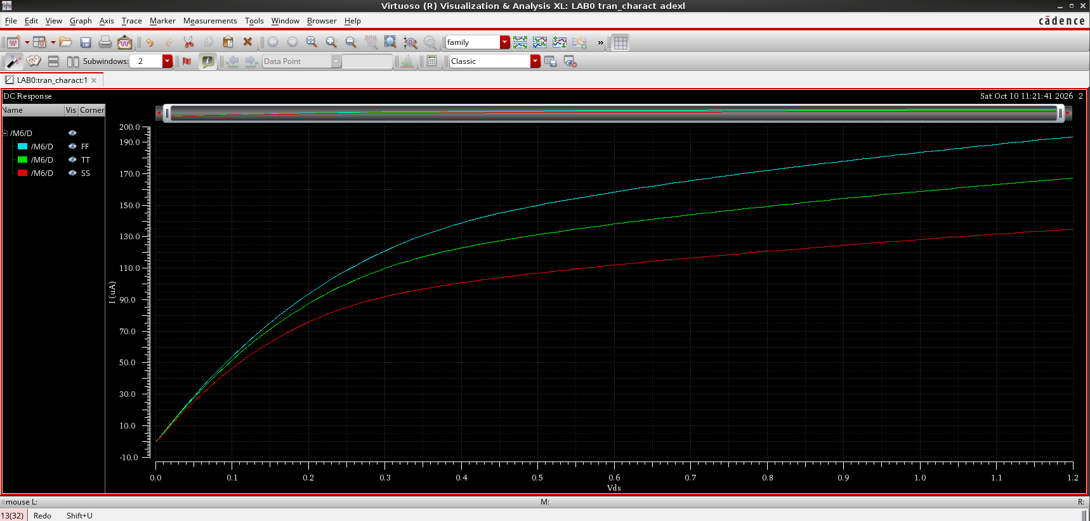
Figure 23: I_{D} versus V_{DS} at fixed V_{GS} across the PVT corners.

Questions
What is the difference between the results when sweeping on F_{n}, M_{n} and W_{n}?
Sweeping M_{n} or F_{n}: the current I_{D} is multiplied by the sweep factor, and the threshold voltage V_{TH} stays practically the same across all PVT corners.
Sweeping W_{n}: the current also increases, but this changes the geometry of the device itself, This causes V_{TH} to shift slightly across the corners.
Search for short channel effects and give a brief about what you understood.
Short channel effects appear when the channel length becomes comparable to the depletion widths of the source and drain junctions. The main ones are:
- Velocity saturation and mobility degradation. In our derivation of I_{D} we assumed that the drift velocity is v = µE. At high electric field the carrier velocity saturates and is no longer linear with E. Because of this, I_{D} stops following the square law and the device saturates earlier.
- DIBL (drain induced barrier lowering). A high drain voltage pulls down the energy barrier at the source side of the channel. This lowers the threshold voltage and makes I_{D} depend more on V_{DS}.
- Loss of gate control. Because the gate’s grip is weakened by the drain’s influence, the transistor never fully turns off and the subthreshold leakage current increases. In addition, the very thin gate oxide of these devices allows quantum mechanical tunneling from the gate to the channel, which is a separate source of gate leakage.
In our simulations these effects show up as the incomplete flattening of I_{D} in the saturation region (Figure 12) and the early saturation of the curves.

5. Task 4: g_{m} Characteristics
In this task we study the transconductance g_{m}. First we plot V_{TH} against V_{GS} (Figure 24). It is just a graph between V_{GS} and V_{TH}, and we clearly see that V_{TH} changes very slightly with V_{GS} (from about 365 mV to 377 mV), so we can treat it as a constant.
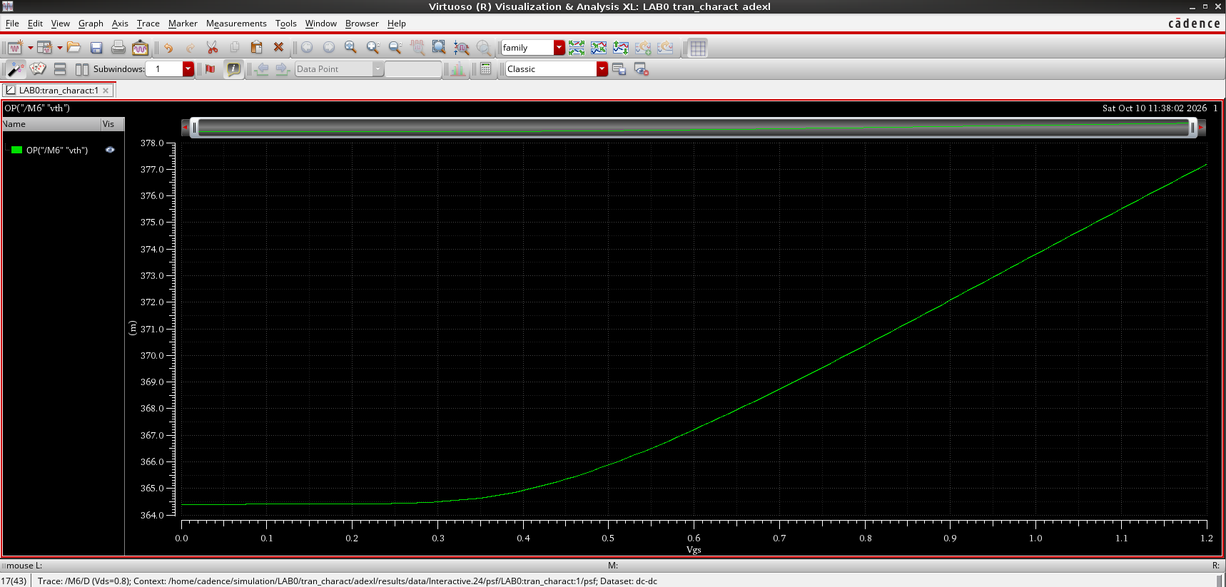
Figure 24: V_{TH} versus V_{GS}.

g_{m} versus (V_{GS} − V_{TH}) at constant W/L
Figure 25 is the graph between V_{GS} and g_{m}, but we want V_{GS} − V_{TH}. For that we made a function in the calculator that subtracts V_{TH} from V_{GS} (Figure 26), and the result is shown in Figure 27.
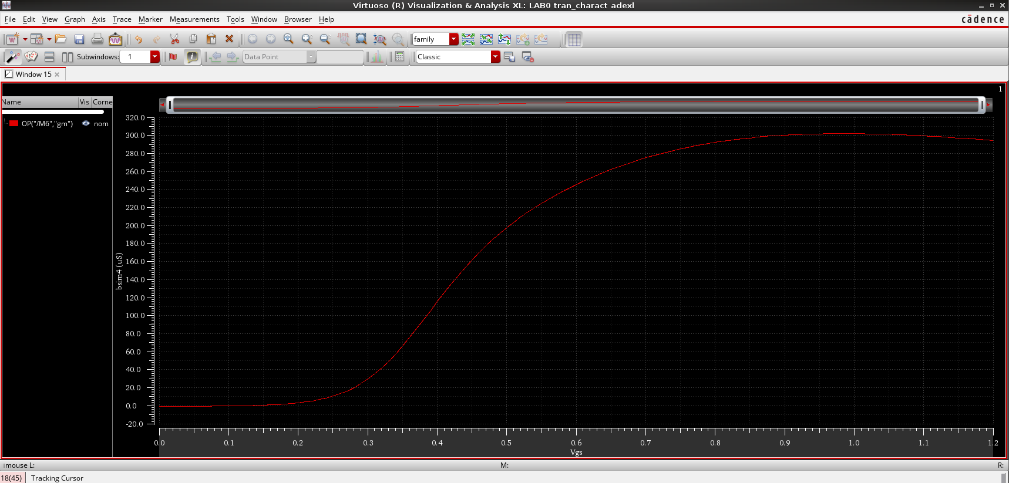
Figure 25: g_{m} versus V_{GS}.
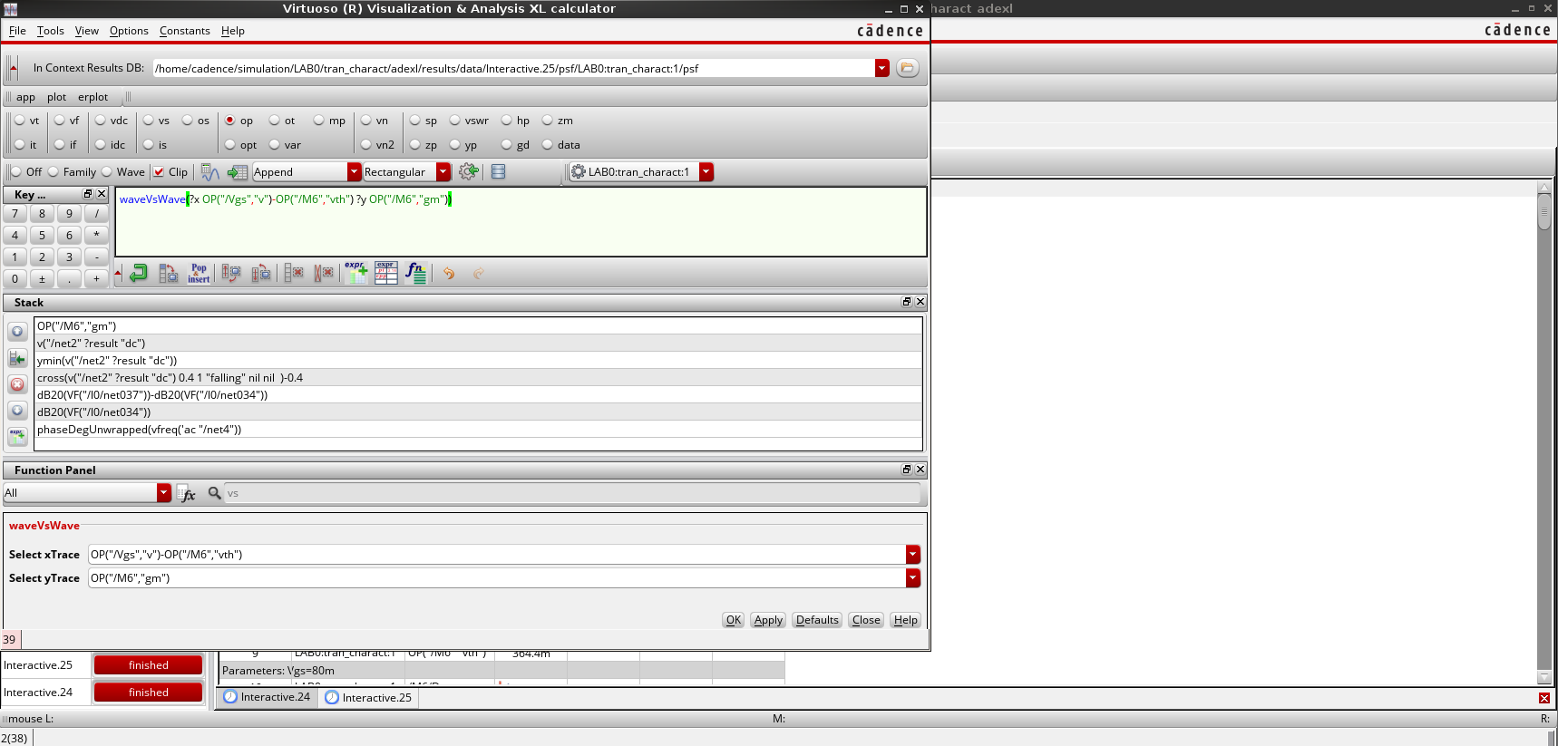
Figure 26: Calculator expression used to plot g_{m} against (V_{GS} − V_{TH}).
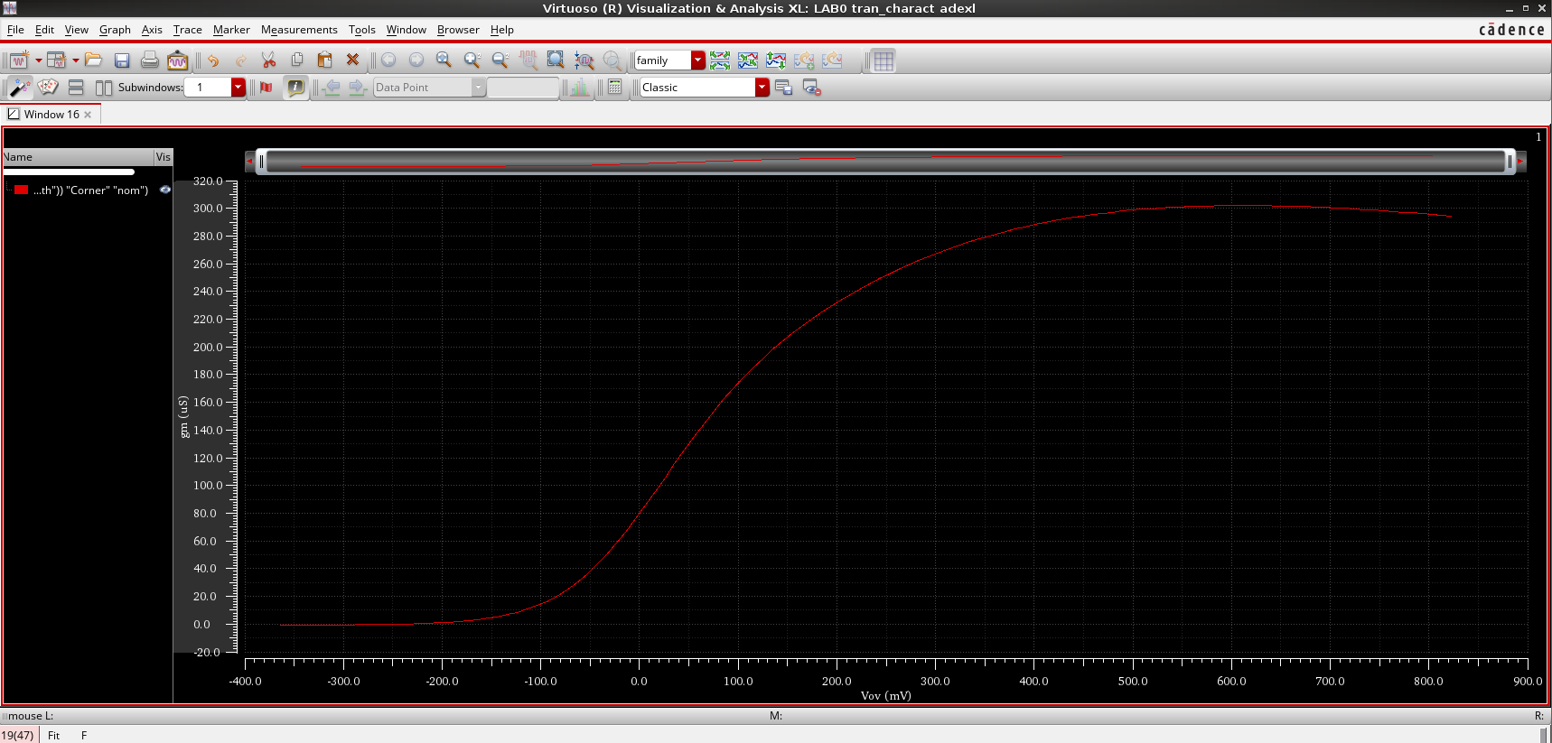
Figure 27: g_{m} versus (V_{GS} − V_{TH}) at constant W/L.
For V_{GS} − V_{TH} below zero the transistor is in weak inversion and g_{m} is very small. Above V_{TH}, g_{m} rises quickly as the transistor goes into strong inversion. In the ideal square-law model, g_{m} = µC_{ox}(W/L)(V_{GS} − V_{TH}) would keep growing linearly, but here the curve bends and flattens at about 300 µS, and it even drops slightly at the end. This is the effect of velocity saturation and mobility degradation in the short channel.

g_{m} versus I_{D} at constant W/L
We use the calculator again to plot g_{m} against I_{D} (Figure 28). The result is shown in Figure 29.
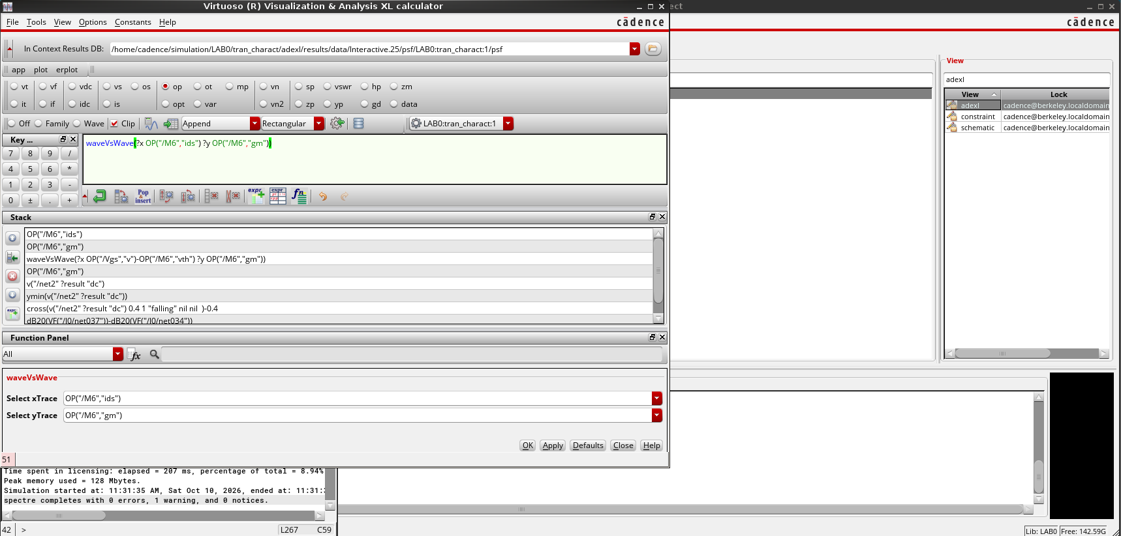
Figure 28: Calculator setup used to plot g_{m} against I_{D}.
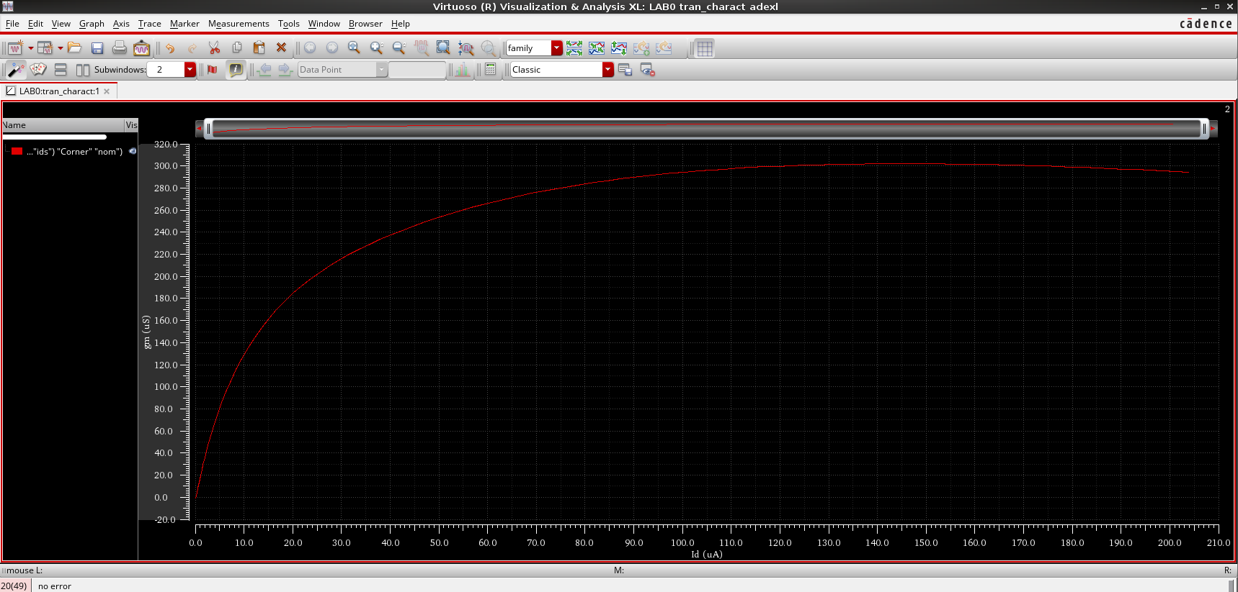
Figure 29: g_{m} versus I_{D} at constant W/L.
g_{m} grows quickly with I_{D} at low current, where the device is in weak inversion and g_{m} ∝ I_{D}. As I_{D} increases the slope drops (the square law predicts g_{m} ∝ √I_{D}), and g_{m} finally levels off at about 300 µS, where velocity saturation takes over and g_{m} no longer depends on I_{D}.

g_{m} versus (V_{GS} − V_{TH}) at constant I_{D}
At constant I_{D}, the only way to change V_{GS} is to change W/L, so every point needs its own width. We tried two approaches.

Method 1: square-law width scaling
First, we swept W_{n} to find the width that gives I_{D} = 1 mA at a few values of V_{GS} (Table 1). The smaller the overdrive, the wider the device must be.
Table 1: Width required for I_{D} = 1 mA at different values of V_{GS}.
V_{GS} (V) | 1.200 | 1.017 | 0.833 | 0.650
W_{n} (µm) | 1.00 | 1.32 | 1.95 | 3.56

To automate this over a full sweep, we kept L_{n} fixed and scaled only W_{n}, since width is the easiest parameter to adjust in practice. From the square law,
I_{D} = ½ µ_{n}C_{ox} (W_{n}/L_{n}) (V_{GS} − V_{TH})²
and holding I_{D} equal to its value at a reference point (V_{GS} = 0.8 V, width W_{ref}) gives
W_{n} = W_{ref} · [ (0.8 − V_{TH}) / (V_{GS} − V_{TH}) ]²
with V_{TH} ≈ 0.4 V. We entered this expression as the design variable of W_{n} (rounded to a 5 nm grid) and swept V_{GS} from 0.8 V to 1.2 V in 10 mV steps (Figure 30). Starting from W_{ref} = 200 nm would give only 50 nm at 1.2 V, which is outside the model's range, and Spectre stopped with error CMI-2440. We raised W_{ref} to 600 nm, so W_{n} runs from 600 nm down to 150 nm.
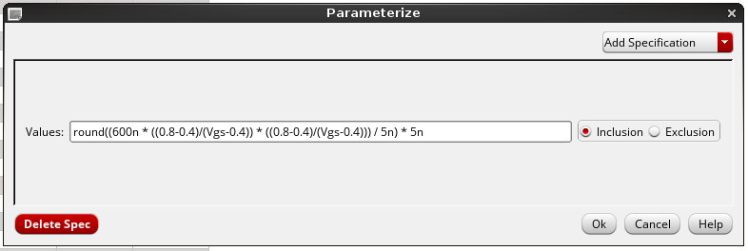
Figure 30: Width expression defined as a design variable of W_{n}.
Figure 31 shows that I_{D} is not constant: it falls from about 268 µA at 0.8 V to about 158 µA at 1.2 V, a drop of 41%. In this short-channel device, velocity saturation makes I_{D} grow closer to linearly with V_{GS} − V_{TH} (an effective exponent of about 1.2–1.3 instead of 2), so the formula shrinks the width too much. V_{TH} also drifts slightly with V_{GS} (Figure 24). With I_{D} swinging between roughly 160 and 270 µA, treating it as constant would be a poor approximation, so square-law scaling is not reliable here. At the widths we did simulate, g_{m} falls from about 870 µS at V_{GS} − V_{TH} = 0.4 V to about 230 µS at 0.8 V. This follows the expected 2I_{D}/(V_{GS} − V_{TH}) trend but stays below it.
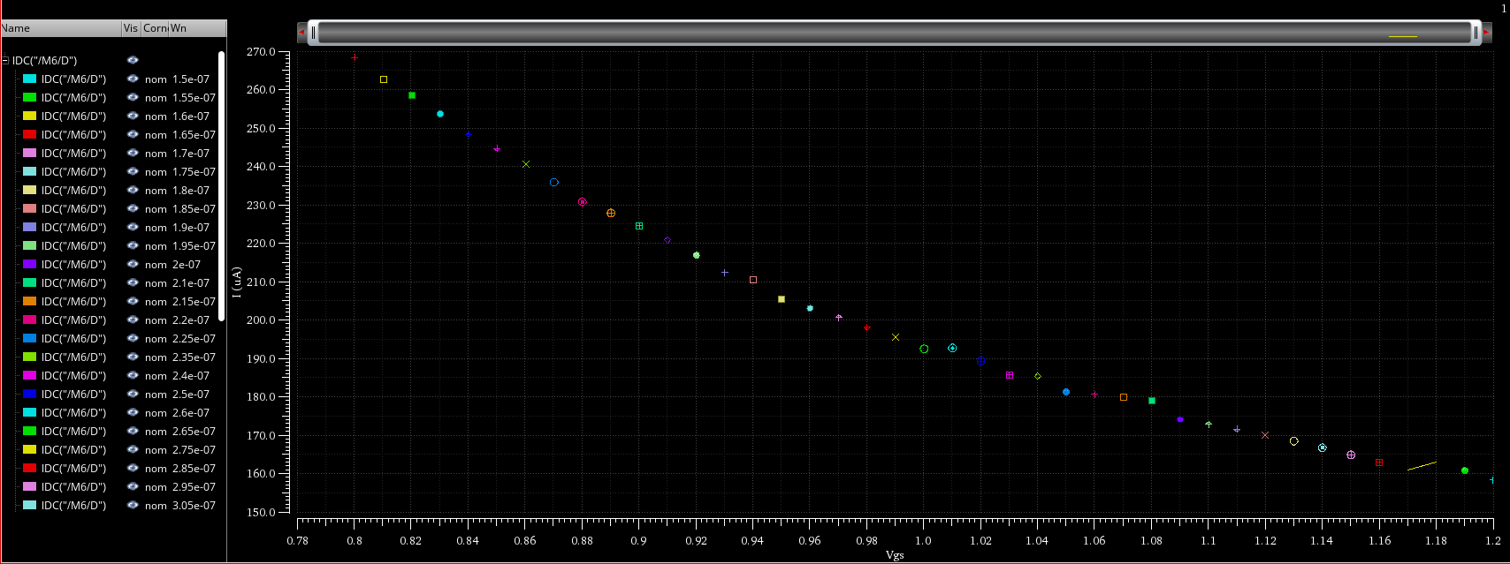
Figure 31: I_{D} versus V_{GS} with W_{n} scaled by the square-law expression.
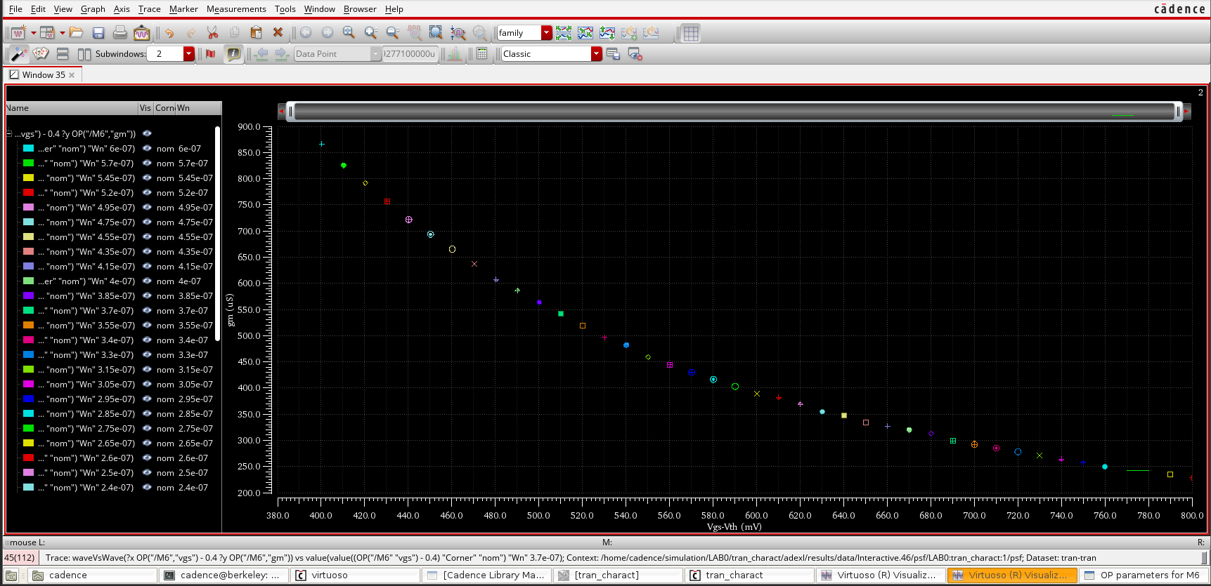
Figure 32: gm versus V_{GS} -Vth with W_{n} scaled by the square-law expression.

Method 2: nested sweep and g_{m}/I_{D}
The ratio g_{m}/I_{D} does not depend on width, so we can simulate once and rescale to any target current instead of resizing the device each time. We ran a nested sweep with V_{GS} from 0 to 1.2 V (20 steps, plus 0.8 V) and V_{DS} from 0.6 to 1.2 V (20 steps), using W_{n} = 200 nm, L_{n} = 60 nm, F_{n} = M_{n} = 1 and V_{TH} = 0.35 V (Figure 32). The I_{D}–V_{DS} data was exported as idvsvds.csv and processed in MATLAB (full script in Appendix A).
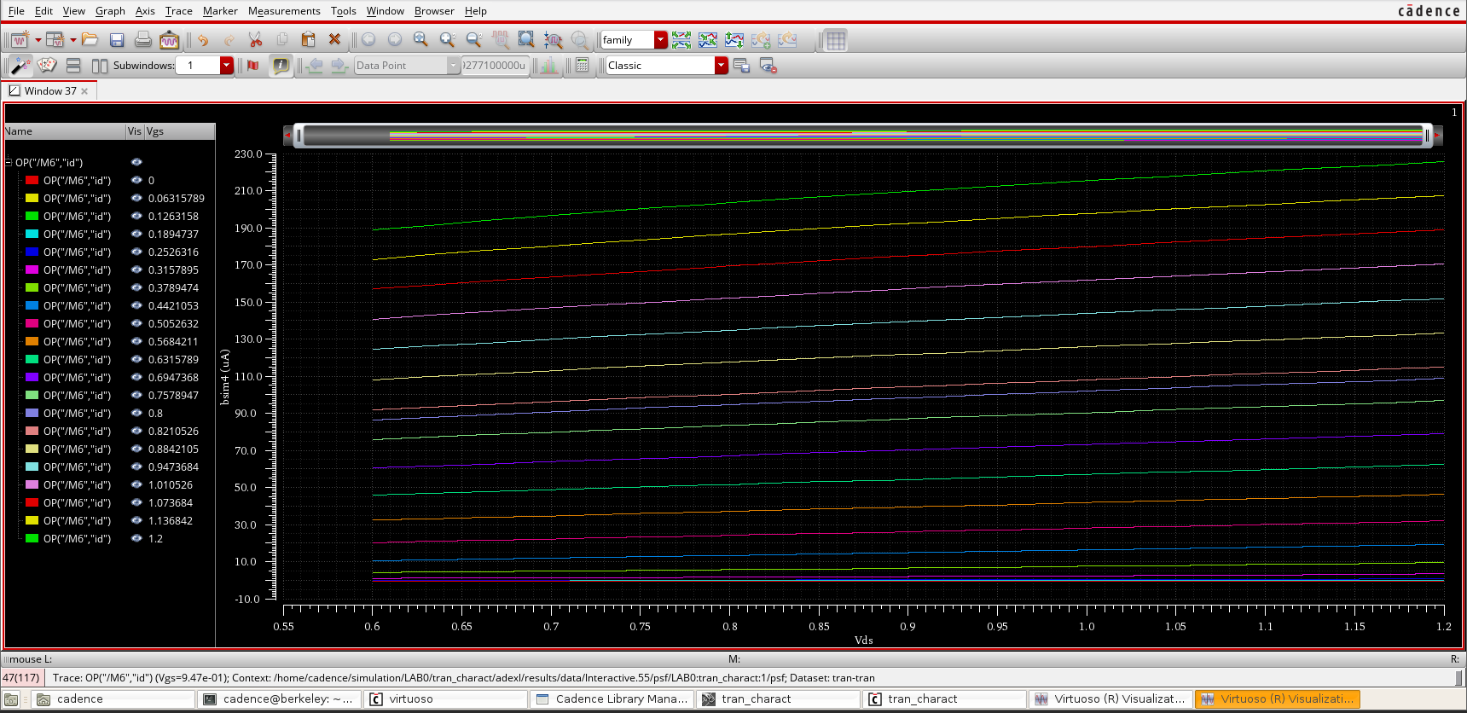
Figure 33: I_{D} versus V_{DS} for the nested V_{GS} sweep.
The script picks a saturation point (V_{DS} = 0.9 V), computes g_{m} = ∂I_{D}/∂V_{GS} across the traces, and rescales it to a target current of I_{target} = 100 µA:
g_{m}(I_{D} = I_{target}) = I_{target} · (g_{m} / I_{D})
Figure 33 plots the result against V_{GS} − V_{TH} together with the square-law curve 2I_{D}/(V_{GS} − V_{TH}).
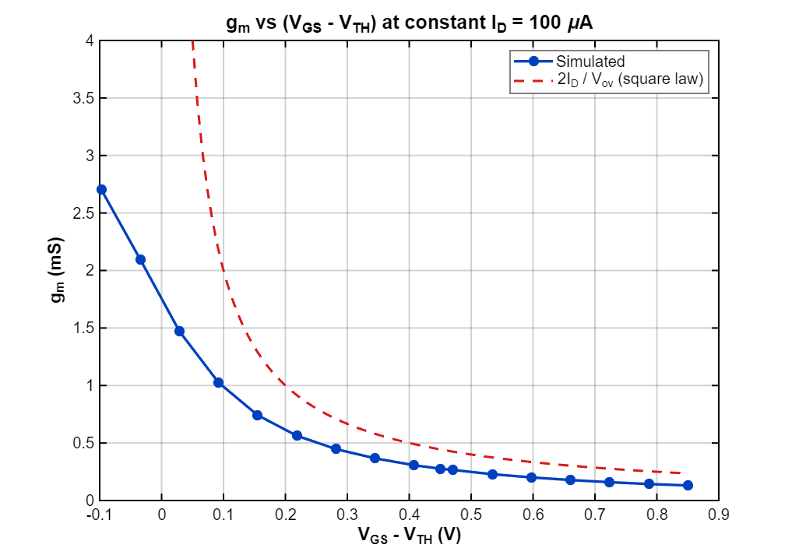
Figure 34: g_{m} versus (V_{GS} − V_{TH}) at constant I_{D} = 100 µA.
g_{m} decreases steadily as the overdrive grows: about 2.7 mS in weak inversion, 1.0 mS at V_{GS} − V_{TH} ≈ 0.1 V, 0.3 mS at 0.4 V and 0.13 mS at 0.85 V. This matches Method 1: at the same current, a small overdrive gives more g_{m} at the cost of a wider transistor. The simulated curve sits below 2I_{D}/(V_{GS} − V_{TH}) because of velocity saturation and mobility degradation. The two diverge near threshold, where the square-law expression blows up while the real g_{m}/I_{D} levels off at about 27 V⁻¹. Because Method 2 uses simulated data and assumes no square law, we consider it the more reliable of the two.

6. Conclusion
In this lab we characterized a 65 nm NMOS transistor with DC sweeps in Cadence. V_{TH} came out at about 0.35–0.4 V from the I_{D}–V_{GS} curve (373.8 mV from the simulator at the nominal corner). I_{D} decreases with L and increases with W, F_{n} and M_{n}. The I_{D}–V_{DS} curves showed cut-off, triode and saturation, and I_{D} was not perfectly flat in saturation because of channel-length modulation and DIBL.
Across PVT corners, FF gave the highest current and the lowest V_{TH} (156.1 mV), while SS gave the lowest current and the highest V_{TH} (498.8 mV). g_{m} levels off near 300 µS because of velocity saturation.
At constant I_{D}, g_{m} falls as the overdrive rises. Square-law width scaling failed to hold I_{D} constant (it dropped by 41%), whereas the nested-sweep g_{m}/I_{D} method gave a reliable result that lies below the square-law prediction, again because of short-channel effects.

Appendix A: MATLAB Script
% MATLAB code: gm vs (VGS - VTH) at constant ID
% Input file: idvsvds.csv (Id vs Vds, 21 Vgs traces). Change I_target and Vth at the top.
clc; clear; close all;

%% Settings
I_target = 100e-6; % constant Id (A)
Vth = 0.35; % threshold voltage (V)
Vds_fix = 0.9; % keep it in saturation

%% Load (col 1 = Vds, even columns = Id for each Vgs trace)
raw = readmatrix('D:\Cadence\idvsvds.csv', 'NumHeaderLines', 3);
Vds = raw(:,1);
Id = raw(:,2:2:end); % rows = Vds, cols = Vgs
Vgs = sort([linspace(0,1.2,20) 0.8]); % 21 traces, legend order
assert(size(Id,2) == numel(Vgs), 'Vgs list does not match number of traces');

%% gm = dId/dVgs across the traces, at the chosen Vds
[~, r] = min(abs(Vds - Vds_fix));
id = Id(r,:);
gm = gradient(id, Vgs);

%% gm at constant Id (W scaled so every point carries I_target)
gm_const = I_target * gm ./ id;
Vov = Vgs - Vth;

keep = Vov > -0.1; % drop deep subthreshold

%% Plot (clean light style, dark readable text)
fig = figure('Color','w','Position',[100 100 820 580]);
theme(fig,'light'); % R2025a+ : forces light theme
ax = axes(fig); hold(ax,'on'); box(ax,'on');

plot(ax, Vov(keep), gm_const(keep)*1e3, '-o', 'Color',[0 0.25 0.75], ...
'LineWidth',2, 'MarkerSize',6, 'MarkerFaceColor',[0 0.25 0.75]);
Vp = linspace(0.05, max(Vov), 100);
plot(ax, Vp, 2*I_target./Vp*1e3, '--', 'Color',[0.85 0.1 0.1], 'LineWidth',1.8);

ax.Color = 'w';
ax.XColor = 'k';
ax.YColor = 'k';
ax.GridColor = [0.3 0.3 0.3];
ax.GridAlpha = 0.25;
ax.FontName = 'Arial';
ax.FontSize = 12;
ax.LineWidth = 1.2;
grid(ax,'on');

xlabel(ax, 'V_{GS} - V_{TH} (V)', 'FontSize',14, 'FontWeight','bold', 'Color','k');
ylabel(ax, 'g_m (mS)', 'FontSize',14, 'FontWeight','bold', 'Color','k');
title(ax, sprintf('g_m vs (V_{GS} - V_{TH}) at constant I_D = %.0f \\muA', I_target*1e6), ...
'FontSize',15, 'FontWeight','bold', 'Color','k');

lgd = legend(ax, 'Simulated', '2I_D / V_{ov} (square law)', 'Location','northeast');
lgd.TextColor = 'k'; lgd.Color = 'w'; lgd.EdgeColor = [0.5 0.5 0.5]; lgd.FontSize = 12;

% Optional: save a high-resolution image for the report
% exportgraphics(fig, 'gm_vs_vov.png', 'Resolution', 300);

